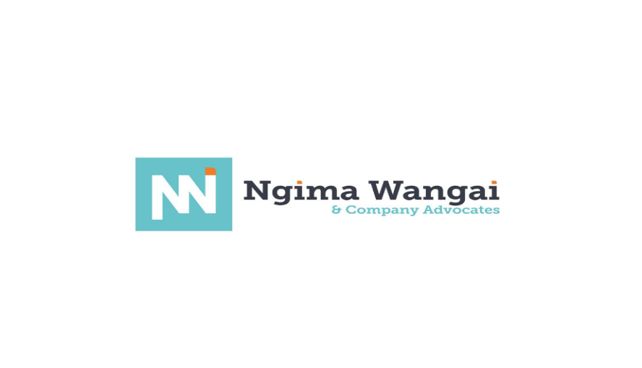

NGIMA WANGAI & COMPANY ADVOCATES
PWA Platform: Administrative Operations & System User Guide
Document Control & Administrative Metadata
- Document Purpose: Operational & Navigational User Guide for System Administrators, Managing Partners, and Firm Staff
- Target Firm: Ngima Wangai & Company Advocates (Nairobi, Kenya)
- Target Audience: Non-technical Administrative Staff, Managing Partners, Legal Associates
- Scope: Operational navigation, client management, content updates, and communication management.

Section 1: Executive System Overview
The Ngima Wangai & Company Advocates Progressive Web Application (PWA) serves as an interactive digital front desk for the firm. It enables prospective and existing clients to learn about the firm's legal practice areas, schedule consultations, and engage in verified, real-time messaging with firm personnel.
Key Operational Capabilities:
- Instant Client Engagement: Captures incoming legal inquiries and connects clients to available firm staff through a unified dashboard.
- Verified Guest Inquiries: Ensures client messages are tied to verified email addresses before reaching staff inboxes.
- Dynamic Practice Area Display: Allows administrative staff to publish, update, or reorganize legal services without requesting technical code changes.
- Client Broadcast Updates: Provides a built-in communication tool to send legal updates, regulatory alerts, and corporate newsletters to subscribed clients.

Section 2: System Navigation & Architecture Map
The following operational map shows how incoming client interactions move through the platform to reach firm administrators.
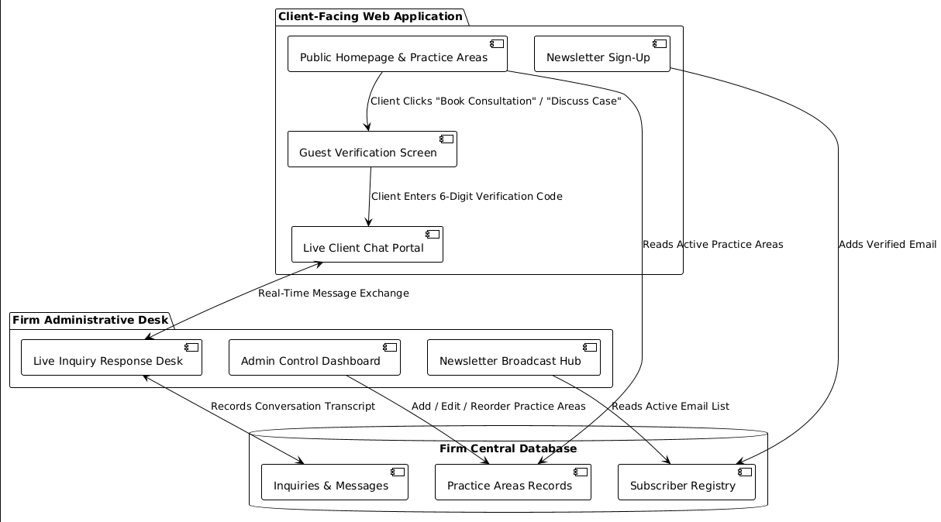

Section 3: Managing Practice Areas & Firm Offerings
Administrative staff can modify the legal practice areas displayed on the public website directly from the administration portal.
Steps to Add or Edit a Practice Area:
- Log into the Firm Administrative Portal using your assigned credentials.
- Navigate to Core > Practice Areas.
- To add a new practice, click Add Practice Area at the top right.
- Fill in the required operational fields:
  - Title: The public name of the legal desk (e.g., Banking & Financial Services Law).
  - Slug: Auto-generated web identifier.
  - Description: A brief summary explaining the firm's capability in this legal sector.
  - Icon Class: Visual symbol selection for web display.
  - Order: A numeric rank determining where the service appears on the home page listing (e.g., 1 for top priority).
  - Is Active: Check this box to publish the service immediately. Uncheck to hide it without deleting the entry.
- Click Save. The website updates automatically across all client devices.

SECTION 4: COMMUNICATION, REAL-TIME WEBSOCKETS & NOTIFICATION PROTOCOLS
The platform utilizes a dual-channel messaging architecture combining low-latency WebSockets via Django Channels for live interaction and background SMTP notifications for offline alerts.
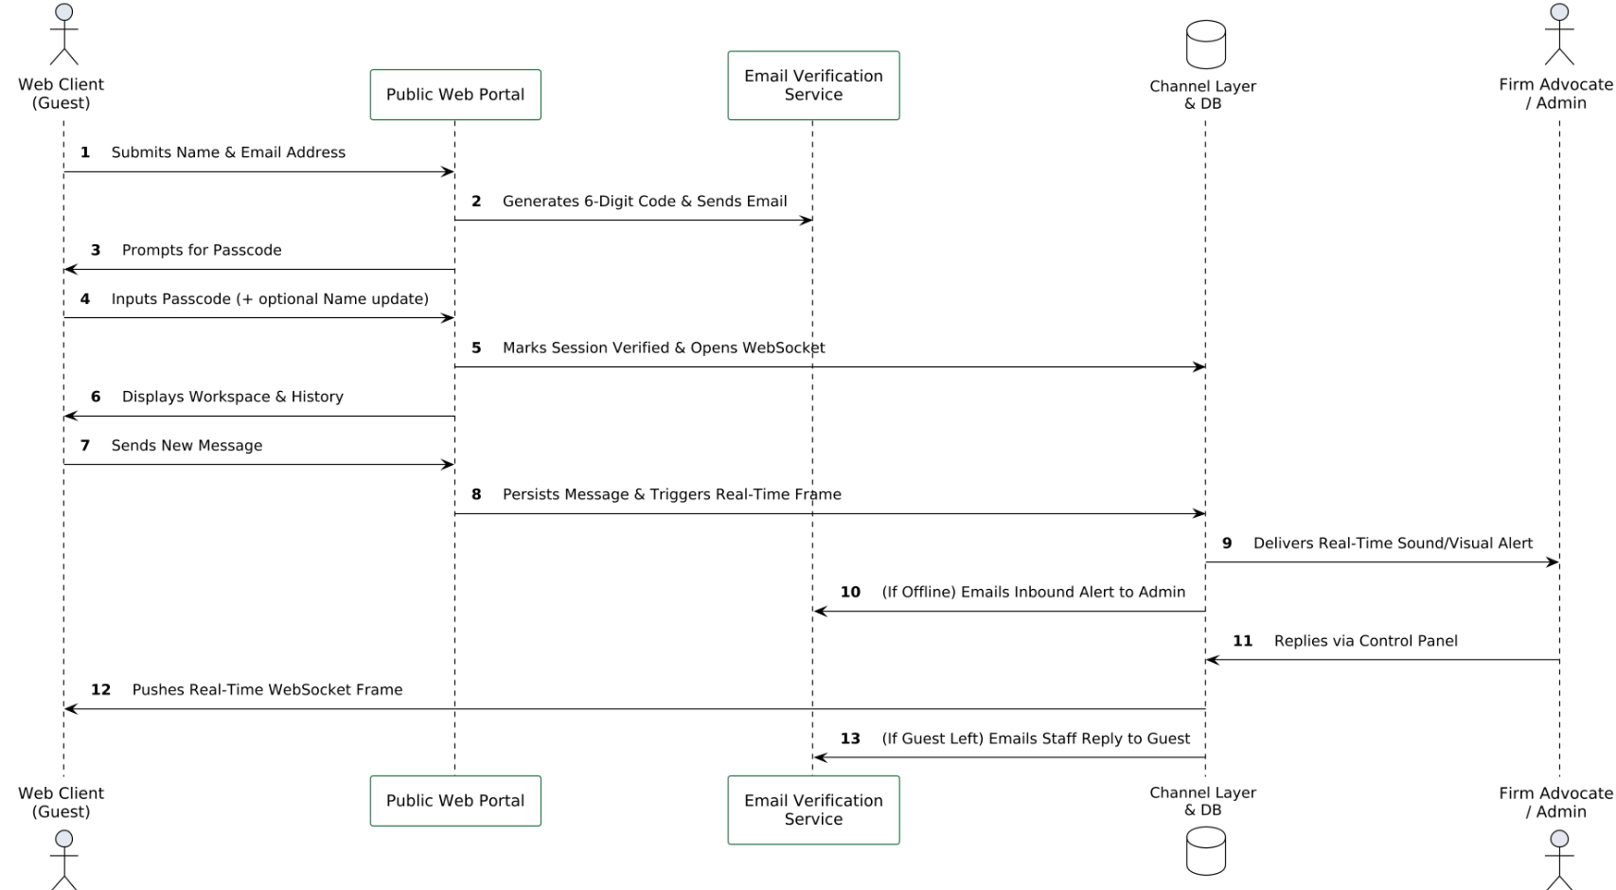

4.2 Detailed Communication Protocols & Notification Handlers

1. Initial Guest Registration & Verification Step
- Form Data Input: The guest inputs their Name (input-name) and Email Address (input-email).
- Code Generation: The system stores an active verification instance via EmailVerification.objects.create() and dispatches a 10-minute validity passcode through SMTP.
- Session Persistence: Upon typing the valid 6-digit code, the server sets request.session['contact_email'] with a 30-day expiration window, preventing repeated verification requests on subsequent visits.

2. WebSocket Real-Time Channel (consumers.py)
- Connection Lifecycle: The client frontend connects to ws://<domain>/ws/chat/. ChatConsumer validates the session email (get_session_email), binds the connection to a unique Redis group via group_name_for_email(email), and accepts the channel connection.
- Dynamic Frame Exchange:
  - When a message is typed, receive() parses the payload, creates a ChatMessage entry assigned to sender='guest', and broadcasts the payload frame across the group channel.
  - Historical transcripts are dynamically loaded using get_messages with cursor-based pagination (before timestamp markers).

3. Automated Administrative & Guest Notifications
To guarantee that inquiries are never missed during off-hours or when users close their browser tabs:
- Admin Notifications for Inbound Messages:
  - Real-Time Badge Alert: If an administrator is currently logged into the administration panel, an active WebSocket listener triggers an immediate audible tone and visual unread message counter badge on the Admin Desk.
  - Fallback Admin Email Alert: If no staff member actively acknowledges the live WebSocket frame within a preset interval, the server dispatches an automated notification email directly to the firm's inbox detailing the guest's name, email, and primary message body.
- Guest Notifications for Staff Replies:
  - In-App Real-Time Push: Responses typed by administrators directly inside the control desk panel automatically push through group_send to appear immediately in the client's chat transcript (chat-bubble-staff).
  - Email Notification on Departure: If the guest disconnects their WebSocket (e.g., closes the browser tab or loses network connectivity), the system formats the advocate's reply into a branded email update with a direct link back to {% url 'core:contact' %} to continue the conversation.

Section 5: Managing Newsletter Subscriptions & Email Campaigns
The platform allows administrators to distribute legal insights, regulatory notices, and company updates directly to subscribed corporate and private clients.
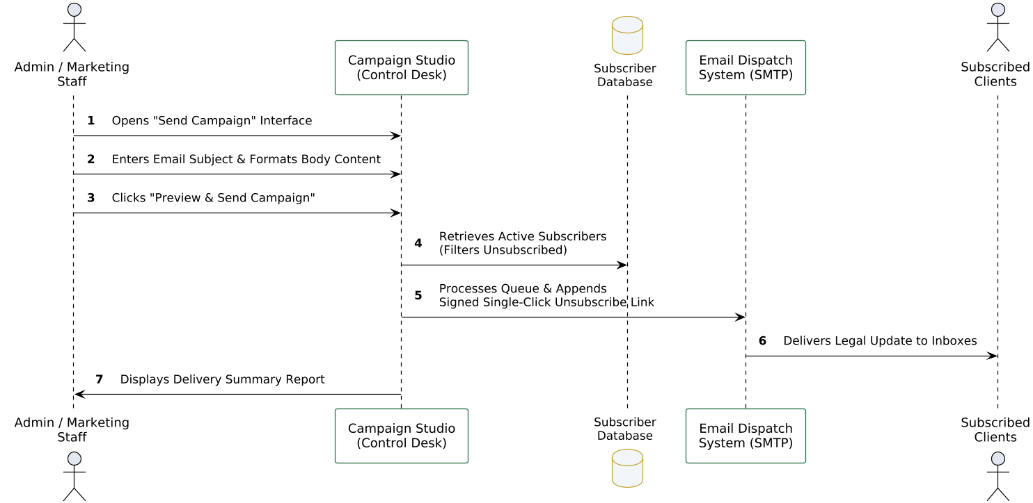
Sending a Legal Broadcast:
- Navigate to Core > Newsletter Subscribers.
- Click Send Campaign at the top right of the dashboard.
- Compose the update:
  - Subject Line: Clear description of the legal update (e.g., Tax Law Regulatory Changes 2026).
  - Content Body: Formatted text, guidance notes, or corporate announcements.
- Click Dispatch Campaign. The system delivers the email to active subscribers while providing an automated single-click unsubscribe link in every footer to maintain compliance.

Section 6: Administrative Control Desk Operations
The administrative overview provides firm management with a high-level operational summary of all portal activities.
Operational Summary Reference Table:
Control Desk Module | Administrative Function | Recommended Operational Frequency
Conversations Portal | Review incoming client inquiries, respond to verified messages, and archive completed cases. | Checked continuously throughout working hours.
Practice Areas Desk | Update descriptions, reorganize priority ordering, or publish new firm practice areas. | Reviewed monthly or during firm service adjustments.
Newsletter Subscribers | Monitor active subscriber lists, review opt-out rates, and dispatch corporate campaigns. | Managed on-demand or bi-weekly.
System Audit Logs | Review staff login activity, message history transcripts, and client contact logs. | Reviewed weekly by managing personnel.

